Poem compression by RLE on bits level

Members:

Mohamed Ahmed Abass

Mohaned Hossam Eldien Mohamed

Mena Fayez

Introduction:

This project is poem compression by RLE on bits.

In this technique of data compression we convert the input text from english letters "ASCII" into zeroes and ones, then we apply RLE data compression algorithm on bits level.

Algorithms:

Compression by RLE on bits level:

First of all we read the input as English text (Poem) and convert it into its binary representation using bitset<8> method which represent every character in the text in 8 bits.

This Project contain 2 core processes Compression and Decompression:

1. Compression process that compress the binary data using the following steps:

(Encoding Algorithm)

* Count the number of 0s between two 1s
* If the number is less than 15, write it down in binary form.
* If it is greater than or equal to 15, write down 1111, and a following binary number to indicate the rest of the 0s. If more than 30, repeat this process.
* If the data starts with a 1, write down 0000 at the beginning.
* If the data ends with a 1, write down 0000 at the end.

1. Decompression process : ( Decoding Algothimn)

* For each 4-bit group, write down that number of 0s.
* If at the end of the bit string, stop.
* If not at the end of the bit string:
  + If the 4-bit group was less than 15, write down a 1 and Go to step 1.
  + If the 4-bit group is 15, go to step 1.

Methods used in the code:

1. Compress() : takes a binary string as parameter and return a compressed binary text.
2. Encode() : takes number of zeros between two ones and return the compressed representation as explained in the compression process.
3. Decompress(): takes a compressed binary string and return the original text.

Flowchart :

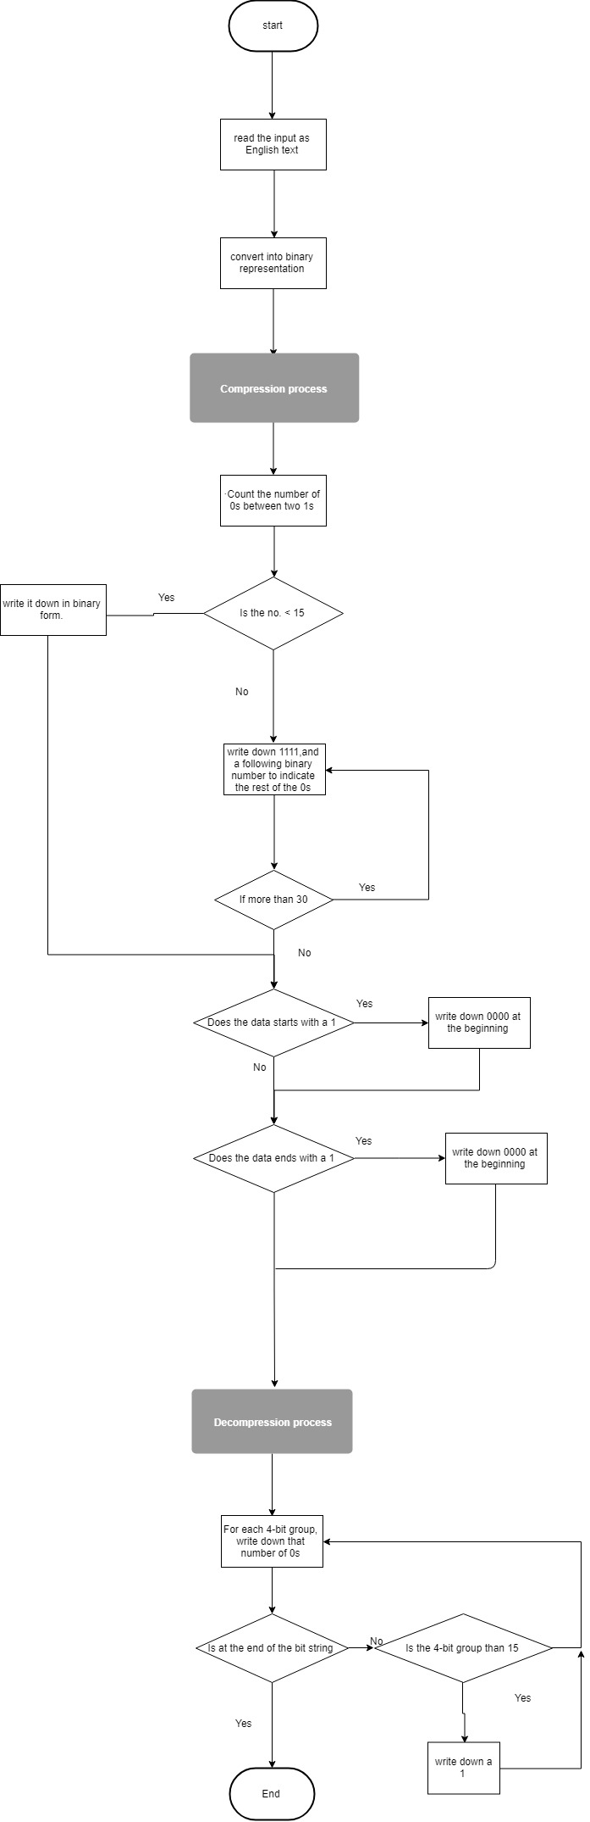

Output sample:

successful compression with compression ratio = 1.77%

The original text after decompression is:

For days now a red-breasted bird has been trying to break in. She tests a low branch, violet blossoms swaying beside her, leaps into the air and flies straight at my window, beak and breast held back, claws raking the pane. Maybe she longs for the tree she sees reflected in the glass, but I'm only guessing. I watch until she gives up and swoops off. I wait for her return, the familiar click, swoosh, thump of her. I sip cold coffee and scan the room, trying to see it new through the eyes of a bird. Nothing has changed. Books piled in a corner, coats hooked over chair backs, paper plates, a cup half-filled with sour milk. The children are in school. The man is at work. I'm alone with dead roses in a jam jar. What do I have that she could want enough to risk such failure, again and again?.

Conclusion:

We have a negative compression.

So we can clearly conclude that the RLE compression on bits level is not useful to be used on this type of text (poem),